**PIZZA SALES SQL QUERIES**

**KPIs**

1. Total Revenue-

SELECT SUM(total_price) AS REVENUE

FROM pizza_sales;

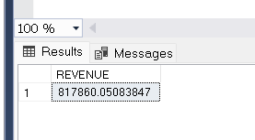

--------------------------------------------------------------------------------------------------------------------------

1. Average Order Value-

SELECT SUM(total_price)/COUNT(DISTINCT(order_id)) AS Average_order_value

FROM pizza_sales;

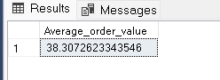

----------------------------------------------------------------------------------------------------------------------------

1. Total Pizzas Sold-

SELECT SUM(quantity) AS TotalPizzasSold

FROM pizza_sales;

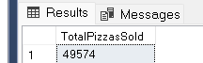

-------------------------------------------------------------------------------------------------------------------------------

1. Total Orders-

SELECT COUNT(distinct(order_id)) AS Total_Orders

FROM pizza_sales;

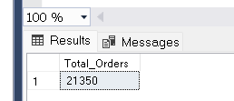

---------------------------------------------------------------------------------------------------------------------------

1. Average Pizza Per Order-

SELECT CAST(CAST(SUM(quantity) AS DECIMAL(10,2))/COUNT(DISTINCT order_id) AS DECIMAL(10,2)) AS AveragePizzaPerOrder

FROM pizza_sales;

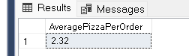

------------------------------------------------------------------------------------------------------------------------------

**CHARTS REQUIREMENT**

1. Total Orders by Days-

SELECT DATENAME(DW, order_date) AS OrderDay, COUNT(DISTINCT(order_id)) AS Total_orders

FROM pizza_sales

GROUP BY DATENAME(DW, order_date);

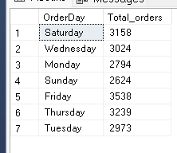

------------------------------------------------------------------------------------------------------------------------------

1. Monthly Trend for Total Orders-

SELECT DATENAME(MONTH, order_date) AS OrderDay, COUNT(DISTINCT(order_id)) AS Total_orders

FROM pizza_sales

GROUP BY DATENAME(MONTH, order_date)

ORDER BY Total_orders DESC;

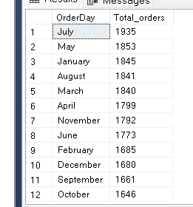

1. Percentage of Sales by Pizza Category-

SELECT pizza_category, CAST(SUM(total_price)*100 / (SELECT SUM(total_price) FROM pizza_sales) AS DECIMAL(10,2)) AS Orders

FROM pizza_sales

GROUP BY pizza_category;

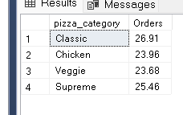

----------------------------------------------------------------------------------------------------------------------------

1. Percentage of Sales by Pizza Size-

SELECT pizza_size, CAST(SUM(total_price)*100 / (SELECT SUM(total_price) FROM pizza_sales) AS DECIMAL(10,2)) AS Orders

FROM pizza_sales

GROUP BY pizza_size;

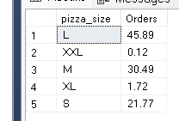

---------------------------------------------------------------------------------------------------------------------------------

5. TOP 5 Pizzes by Revenue-

SELECT TOP 5 pizza_name, SUM(total_price) AS Total_Revenue

FROM pizza_sales

GROUP BY pizza_name

ORDER BY Total_Revenue DESC;

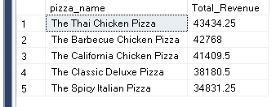

-------------------------------------------------------------------------------------------------------------------------------

1. Bottom 5 Pizzas by Revenue-

SELECT TOP 5 pizza_name, SUM(total_price) AS Total_Revenue

FROM pizza_sales

GROUP BY pizza_name

ORDER BY Total_Revenue;

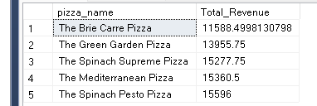

----------------------------------------------------------------------------------------------------------------------------

1. TOP 5 Pizzas by Quantity-

SELECT TOP 5 pizza_name, SUM(quantity) AS Total_quantity

FROM pizza_sales

GROUP BY pizza_name

ORDER BY Total_quantity DESC;

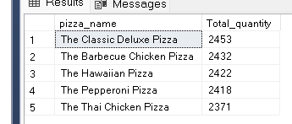

1. Bottom 5 Pizzas by Quantity-

SELECT TOP 5 pizza_name, SUM(quantity) AS Total_quantity

FROM pizza_sales

GROUP BY pizza_name

ORDER BY Total_quantity;

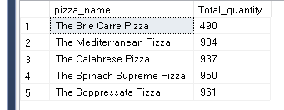

------------------------------------------------------------------------------------------------------------------------------

1. TOP 5 Pizzas by Total Orders-

SELECT TOP 5 pizza_name, COUNT(DISTINCT order_id) AS Total_orders

FROM pizza_sales

GROUP BY pizza_name

ORDER BY Total_orders;

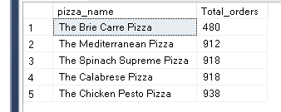

---------------------------------------------------------------------------------------------------------------------------

NOTE-

If you want to apply the pizza_category or pizza_size filters to the above queries you can use WHERE clause. Follow some of below examples

SELECT Top 5 pizza_name, COUNT(DISTINCT order_id) AS Total_Orders

FROM pizza_sales

WHERE pizza_category = 'Classic'

GROUP BY pizza_name

ORDER BY Total_Orders ASC